1/18/2022

**“Open Ended Problem”**

Abdul Moiz SE-19022

Nizam Ali SE-19025

Kabeer Ahmed SE-19028

Mateen Brohi SE-19035

Rehan Mumtaz SE-19036

Sufiyan Irfan SE-19037

Wajahat Ahmed SE-19038

Abdullah Saleem SE-19042

Abdul Khalique SE-19098

Shahid Ali CE-19189

1. What is the problem?

**KARACHI – A CITY OF POTHOLES:**

Karachi, once known as a city of lights is screaming for help! Being a Karachite, it is truly devastating to see this metropolis going down the drain. This city with infinite potential has always welcomed everyone with open arms, regardless of their caste, religion and ethnicity. Throughout the decade, even the most influential people have tediously been fighting for its ownership, but sadly all have failed to shower the love it truly deserves.

Amidst the water crisis, power shortages, pollution and lack of proper waste management, another grave matter that requires our immediate attention are the dilapidated roads. Negligence and lack of infrastructure planning over the years has caused detrimental damage to the citizens, thereby exposing them to hazardous potholes. Potholes are more than just ugly, they can also be dangerous, causing damage to vehicles and potential trip and fall accidents for pedestrians as well as motorcyclists (since majority of the travelers use this mode of transportation).

Here are five reasons why municipality should tackle this pavement issue as soon as possible:

1- Due to these potholes, patients not only suffer a bumpy ride all the way to the hospital, but the ever-increasing rush of heavy traffic on the roads often results in loss of human life. During monsoons, these potholes become a mosquitoes’ hatchery which results in vector borne diseases such as malaria and dengue. Adding to the misery of a common man, officials don’t seem to care much about taking any action to resolve these issues.

2- We have all been confronted with poor road conditions and a plethora of cases have occurred where fatal crashes caused by head-on collisions are directly related to dreaded potholes. The most obvious pothole damage affects a vehicle’s tire. As the tires of a vehicle are always in contact with the road, the force, if severe enough, can misshape the tire, rupture it, or even bend its rim. Other immediate damages that can occur from a pothole include scratches, dents, leaks and compression of the suspension.

3- While these potholes slow the commute to a crawl for many, they also add to the woes of customers who are anticipating for their food. One unexpected bump or pothole will easily spill, splatter or ruin the food.

4- Motorcycle drivers are at special risk of injury if they ride over a pothole. Having just two wheels on the ground and a lower weight than cars, motorcycles are ill-equipped to handle potholes. It also adds to the misery of reckless bus and rickshaw drivers who bounce off speedily while carrying an overload of passengers, further putting everybody’s life at a risk.

5- Walking is a common mode of transport in Pakistan, but is increasingly dangerous due to the associated risk of road accidents. Nowadays, pedestrians are in danger of becoming the new victims of potholes, as they run the risk of tripping and injuring themselves. When Pedestrians do not pay attention while walking or crossing the street, they can trip over a pothole which may result in a bad fall injury. Injuries are often serious when a pedestrian is hit, as they have no form of protection being outside of a vehicle. Myriad cases in Karachi have occurred where pedestrians, especially children, have accidentally stepped on a pothole, thinking it’s a puddle when in actuality it turned out to be a manhole. It is impossible to prevent potholes from forming, as there are many reasons for their existence.

2. How the problem can be solved?

ROADS in many areas of Karachi have far too many potholes. These cause traffic accidents and delays. Vehicles suffer damage to their suspensions, which carry a high repair cost. With the monsoon season coming up, with each rainfall, more degradation in the surface and quality of the road structure is observed.

**How they are formed**

• Potholes begin after rain or snow seeps into the soil through a crack in the pavement and flows below the road surface.

• The moisture freezes when temperatures drop, causing the ground to expand and push the pavement up.

• As temperatures rise, the ground returns to normal level but the pavement often remains raised. This creates a void between the pavement and the ground below it.

• When vehicles driver over this cavity, the pavement surface cracks and falls into the hollow space, leading to the formation of a pothole.

Pothole Problem can be solved by using prevention method before potholes happen. By sealing cracks early on and using preservation treatments, potholes can be prevented.

**Preventive Treatments**

**Crack Treatments:**

Consist of placing specialized materials into prepared cracks to prevent water and incompressible intrusion into the cracks and underlying pavement layers.

• Reduce potholes

• Slow pavement deterioration

• Slow crack spalling

**Fog Seals:**

A light application of a diluted slow-setting asphalt emulsion to the surface of an aged pavement surface.

• Help prevent water intrusion

• Slow pavement deterioration

• Improves aggregate retention

**Chip Seals:**

A thin surface treatment that combines one or more layer(s) of asphalt with one or more layer(s) of fine aggregate.

• Help prevent water intrusion

• Fill and seal pavement distresses

• Minimizes reflective cracking

**Micro surfacing:**

A thin surface treatment that combines a layer of asphalt emulsion and finely crushed stone.

• Help prevent water intrusion

• Corrects minor rutting

• Fast set and cure times

**Funding Arrangements:**

In local highway authorities, highway maintenance is funded through a combination of capital and revenue funding. Capital funds come in part via the Local Transport Capital Settlement from central Government. In recent years, even though overall capital budgets have reduced, highway maintenance budgets have remained relatively stable.

**Structural maintenance:**

This consists of structural enhancements that extend the service life of existing highways either by restoring structural capacity through the elimination of age-related surface cracking, or by strengthening existing highways to accommodate existing or projected traffic.

**Permanent and temporary repair:**

It is for each local highway authority to determine its approach to repair. Pothole repairs have been found to include temporary, permanent, and semi-permanent treatments, but there are no standard definitions for how long these treatments should be in place. Temporary repairs are mainly used when a defect is being made safe until a more permanent solution is delivered. Temporary repairs are often undertaken in the knowledge that a permanent repair will be undertaken within 28 days or within the life expectancy of the material used. Some authorities use temporary repairs that will be in place until a wider repair programmed is undertaken.

**Effectiveness Of Pothole Operations**

**Implementing policy:**

Managing potholes involves identification, reporting, assessment, decision making and repair. An effective inspection, assessment and recording regime provides the basic information for local highway authorities to address the core highway maintenance objectives of customer service, network safety, serviceability and sustainability. Such a regime provides support in delivering an efficient service and responding to claims. Authorities undertake formal safety inspections to identify all defects likely to create danger or serious inconvenience to highway users and the wider community. Highway inspectors assess the risk on site against local policy and the result is recorded and categorized for action. Inspection manuals should lead to consistency of approach and to a more easily understood public response to reports. Not all authorities use inspection manuals, and where they are not available, there is a risk of inconsistency in how defects are assessed and associated response times.

**Technology:**

Technology can, and does, play a major part in pothole operations. Many local highway authorities use various technologies as part of their approach to pothole operations. However, this Review has found that some authorities continue to rely on manual input of inspections to their highway management systems. Typical technology that may be beneficial to an authority in the effective and efficient identification, assessment and response to potholes include:

Internet based facilities - These are often linked to an authority’s maintenance management system and provide the opportunity for the public to report highway defects, including potholes, at any time.

Mobile hand-held devices - These enable highway inspectors to record defects immediately and can be linked via wireless to the maintenance management system, allowing the inspector to control the management and response to each defect.

Integrated suite of technology products - These can reduce the number of data entry interventions and also enable an instruction to repair a defect to take only minutes from the moment a pothole is identified. There is potential for significant efficiency savings.

These are some methods for preventing pothole before their happening but what of those which are already been formed?

The first thing which should be done regarding this issue that the government should have certain amount of data to identify the number of potholes and their severity which can be done by taking some technical steps.

3. List all the possible technical solutions?

**All Possible Technical Solutions:**

**1. Pothole Detection Using Arduino and Ultrasonic Sensors**

Ultrasonic sensors will be installed on public transportation and private automobiles. Potholes and humps are detected using ultrasonic sensors. They also take measurements of their depth and height. Using a GPS receiver, the suggested method gathers the geographical location coordinates of potholes and humps. The database stores the detected data, which includes pothole depth, hump height, and geographic position (cloud). This is a vital source of information for both government officials and vehicle operators.

Since in this solution the cost of the vehicles will become very high and people have not enough money to buy these vehicles. They will buy the normal vehicle in which there is no sensor detection which is cheaper as a result this solution will fail. Coming to public vehicles, first of all the government does not support and does not provide money to the public vehicles holders that’s why they are in such bad conditions. Owners drive the public vehicles on their own expense. They will also not spend so much money on digitalizing their vehicles. Here the solution also fails.

The solution is very good and efficient as it will minimize the accidents but the only problem is that it is not cheaper. This solution is very expensive. So, it will not be considered as most economically viable solution.

**2. Pothole Detection using Accelerometer**

Accelerometers are used as sensors in the vibration-based technique. This is a device that measures the sensor's total specific external force. The accelerometer is an electromechanical device that monitors all three axes of vibration. The left-right movement of the phone correlates to the X axis deviation. When the phone is pushed back and forth, the Y axis shifts. When the phone is pushed up and down, the z axis shifts. The Z axis is used to identify anomalies. The accelerometer is frequently designed in a fairly basic manner. Using the sensors available in a smartphone, a smartphone-based solution for pothole detection can be created.

Since this solution is based on smartphone it can be the suitable solution because everyone has smartphone and using this technique user will be able to detect that the pothole coming in his way will be of how much height, how much depth, how much force it will exert, is it danger or not, all the possible solutions will be given through smart phone. The movement of phone will detect all the measurements of upcoming pothole. This solution is viable because user can do the motion of his phone very easily. Almost all the people have smart phone in their pockets and it is easy to install this kind of application having sensors to detect the measurements of pothole in their phones. This will cost very low and no one will have issue and everyone will use it happily as a result decreasing/ minimizing the chance of accidents.

But the problem is that will user while driving all the time he has to keep his smart phone in his hand and keep on moving it. This is a real challenge for driver.

**3. Image Based Pothole Detectors**

Pothole identification using two-dimensional (2D) images captured by street cameras is also a promising option for detecting potholes. A wide range of image processing and object detection algorithms are used in computer vision approaches to automate pothole detection. A black-box camera can also be put on a vehicle's front windscreen and can identify potholes in real time. On an embedded board in the black-box camera, a pothole-detection algorithm is implemented. This method gathers data on the size and position of potholes, which is subsequently stored in a black box and sent to a pothole-management server.

It is the riskiest solution but more robust solution involving high end technologies. It will cause high expense in terms of higher professionals and technical team. Expense will be done in buying high street cameras and black box camera on vehicles in identifying potholes. Furthermore, public will not accept this as the implementing camera in their vehicles is not possible and this technique cannot work if any of the camera is not available. Public will deny as cameras are very expensive so it is highly cost. Although it will be totally technology based so chances of error will also arise because handling huge data and sending it to every vehicle which is running on the road is very risky so it is possible that the system may be crash and it is very expensive.

**4. Manual Detection of Potholes**

People can also report potholes using a Google form or an application, which allows them to define the specific position and severity of the pothole. Officials from the government will have access to all relevant information about potholes and will be able to take appropriate actions accordingly.

It can be the most viable solution as it directly notify the higher officials of government about the potholes to identify them and they can take appropriate measures but in Pakistan unfortunately, if any problem is reported it is actioned after a very long time like six months to a year, and potholes continue to appear as the material used in construction is of worst quality. So, adopting only this technique as a solution of the problem will not help us. It must be connected with other technique as well in order to be successful.

4. Suggest / Select most economically viable solution?

**Most Viable Solution:**

The most viable solution can be the combination of 2 techniques discussed above which is “Pothole Detection Using Accelerometer” and “Manual Detection of Pothole”. People will notify the higher authorities until they take the actions the drivers can use their mobile phones to detect the potholes using sensors in their applications which is a very cheap and easy way and everyone can adopt this method since no investment will be done by people. So, combining these two techniques will help us to overcome this problem and accidents will be minimized.

5. Give reason of your suggestion/selection in 4.above.

**CURRENT ROAD SAFETY SITUATION**

In Pakistan a road traffic fatality is currently defined as ‘died at the scene of the accident’, however this definition is not standardized and results in some provinces also recording deaths which occur during transport and/or arrival at hospital. The global best practice standard is to record all death using the definition ‘died within 30 days of road traffic accident’. Non-fatal road traffic injuries reported to Police are also recorded. However, as there is no uniform, nationally agreed serious (‘grievous’) injury definition, the number and proportion of serious injuries is unknown. The NH&MP collect data relating to crashes which occur on the 2,861 km of roads currently under their authority, including 2,182 kms of national highway on the N-5, sections of the N-25 West and sections of the Coastal Highway on 679 kms of motorway, including the M-1, M-2 and M-3 (NH&MP, Year book 2016-17).14,15 Motorway crash data are generally accepted to be the most comprehensive and reliable.

**Reasons**

1. Governments undertake some sort of economic viability analysis (also referred to as socio-economic viability) to make a decision whether or not a planned project may be a smart use of public resources. A project is economically viable if the economic advantages of the project exceed its economic costs, once analyzed for society as a whole.

The most viable solution can be the combination of 2 techniques discussed above which is “Pothole Detection Using Accelerometer” and “Manual Detection of Pothole”. The economic cost of the project is not the same as its financial cost; Externalities and environmental impacts must be considered. Externalities (positive or negative) are economic impacts that affect people who are not necessarily part of the project scope. Economic benefit is a measure of the value the project will bring to society as a whole.

The revenue that a project will generate is usually an estimate of the lower bound of its economic benefits; However, the benefits can be much greater than the income. For example, the benefits of better transportation to drivers can far outweigh the tolls paid on a highway: faster connections, less vehicle maintenance, lower accident rates can all be important factors. In addition, the project can improve regional economic activity and the quality of life of people living in the vicinity of the project.

it is a cost-effectiveness and lowest-cost alternative to achieve the identified benefits.in Pakistan Federal roads are controlled by the Government of Pakistan and maintained by the National Highway Authority. As we know the status of roads of the Karachi on every 500m there is a pothole. Pakistan's road laws have become outdated and are in need of comprehensive review and modernization. Many things have changed since they were made, such as changes in technology, increases in road traffic and the decentralization of responsibilities to Provinces.

This approach can detect potholes in a comprehensive environment at a lower cost. This study proposes a pothole detection method based on mobile detection. The accelerometer data is normalized by calculating the Euler angle and fed into the pothole detection algorithm to obtain the pothole information.

2. The pothole detection using accelerometer is to know the certain outcomes before occurrence of any incident in case of any people who is to face potholes. It will forehead tell us about how much height, how much depth, how much force it will exert, is it danger or not, all the possible solutions will be given through smart phone. The movement of phone will detect all the measurements of upcoming pothole. This solution is easiest for its stakeholders to be used hence it will be a usable system, and it has no cost for it uses as it will be done through mobile application installation just so it will be economically best solution. It has the maximum probability of decreasing accidents leading to injuries too.

The other possible way to avoid accidents due to potholes is by manual detection of potholes. It will be also best way incorporating citizens of Pakistan data submitted to complaint portal to local authorities, organizations, concerned politicians and other social workers as well, they all will have required data as per areas and its quantity of potholes. If data collected manually is properly applied into data science it could also be beneficial. In order to be successful, it must be linked to other techniques. Manual detection of potholes. Economically, it can be viable solution so keeping in mind the current and future economic situation of country, manual pothole detection can also bear fruitful results resulting in less accidents. Its value create and this society could save cost as it requires no tools, processes and other physical things to solve this problem.

6. Paper Wireframe

**Screen 1:**



**Screen 2:**



**Screen 3:**

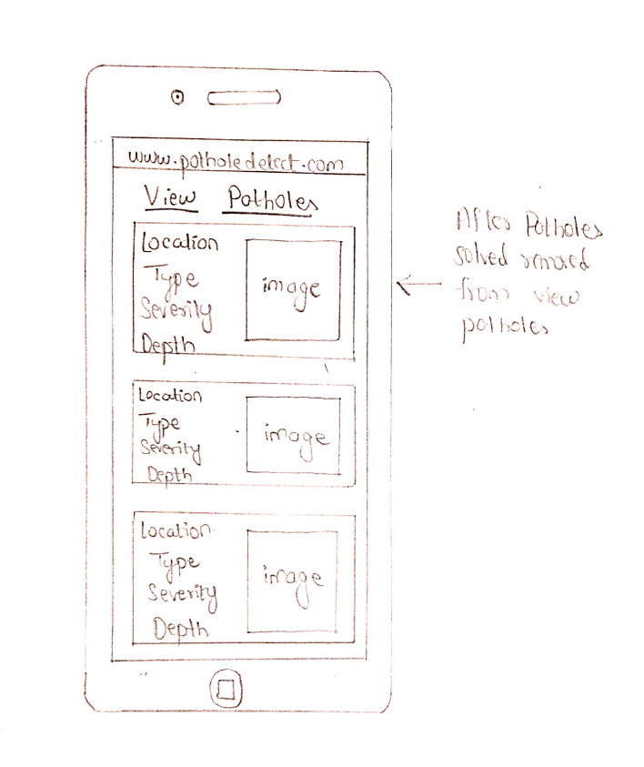

**Screen 4:**

